AgroPrice SL(Farmer Market Price Information System)

TABLE OF CONTENTS
- Chapter 1: Introduction ............................................. 1
  - Background
  - Problem Statement
  - Project Overview
  - Objectives
  - SDG Alignment
- Chapter 2: Software Development Life Cycle (SDLC) ............. 4
  - Agile Methodology
  - Functional Requirements
  - SDLC Phases Summary
- Chapter 3: System Architecture Design .......................... 6
  - Architecture Overview
  - Architecture Diagram
  - Use Case Diagram
  - Class Diagram
  - Sequence Diagram
- Chapter 4: Database Design ...................................... 9
  - Database Overview
  - ERD Design
  - Table Schemas
- Chapter 5: Prototype Development ............................... 11
  - Design Overview
  - Figma Prototype
  - Mobile Screens
  - Desktop Screens
- Chapter 6: Git & GitHub Integration ............................ 13
  - Repository Overview
  - Repository Structure
  - Branch Strategy
  - GitHub Screenshots
- Chapter 7: Project Management .................................. 15
  - Project Activities
  - Gantt Chart
  - Network Diagram (CPM)
- Chapter 8: License, Design Quality & SDG Relevance ............ 17
  - MIT License
  - UI/UX Design Quality
  - SDG Alignment Matrix
- Chapter 9: Conclusion and Recommendations ..................... 19
  - Summary
  - Achievements
  - Recommendations
  - Conclusion
References .......................................................... 20

Abstract

AgroPrice SL is a Digital Public Good designed to eliminate agricultural market price inequality in Sierra Leone. Over 60% of Sierra Leone's population depends on farming, yet smallholder farmers consistently receive below-market prices for their produce due to a critical lack of price information. Middlemen exploit this gap, deepening rural poverty.

This report presents a complete software design for AgroPrice SL — a web-based and SMS-accessible Farmer Market Price Information System. The system delivers real-time commodity prices, SMS alerts, market maps, and analytics, built on a three-tier architecture (React.js, Node.js, PostgreSQL) using the Agile SDLC. The project includes UML diagrams, database schema, a 10-screen Figma prototype, GitHub repository, and project management tools.

AgroPrice SL aligns directly with UN SDG 1 (No Poverty) and is licensed under the MIT License as an open-source public good.

Keywords: Digital Public Good, AgroPrice SL, Agile SDLC, Sierra Leone, Farmer Market Prices, SDG 1, SMS Alerts, PostgreSQL.

Chapter 1: Introduction

1.1 Background
Sierra Leone is an agrarian nation where over 60% of the population depends on agriculture. Despite this, smallholder farmers remain among the poorest citizens due to a critical lack of market price information. When farmers arrive at markets, they have no knowledge of prevailing commodity prices, allowing traders to offer prices far below market value. This information asymmetry perpetuates rural poverty.

1.2 Problem Statement
- Farmers sell crops at below-market prices due to price ignorance.
- Middlemen exploit the information gap to dictate unfair prices.
- Post-harvest losses occur because farmers cannot identify optimal selling times.
- Women farmers and rural communities are disproportionately affected.

1.3 Project Overview
AgroPrice SL is a Digital Public Good — a web-based and SMS-accessible Farmer Market Price Information System that provides real-time agricultural commodity prices across Sierra Leone's districts and markets.

1.4 Objectives
- Provide real-time, district-specific agricultural commodity prices.
- Deliver SMS price alerts for farmers using basic mobile phones.
- Enable market officers to enter and update price data easily.
- Display price trends and market locations on interactive maps.
- Operate as an open-source Digital Public Good under the MIT License.

1.5 SDG Alignment
AgroPrice SL directly aligns with UN Sustainable Development Goal 1: No Poverty — empowering farmers to earn fair value for their harvest, reduce exploitation, and improve livelihoods across Sierra Leone.

Chapter 2: Software Development Life Cycle (SDLC)

2.1 Selected Model: Agile
The Agile SDLC was selected for AgroPrice SL because requirements may evolve as farmer feedback is gathered, sprints enable iterative delivery of working features, and the model supports stakeholder collaboration from farmers to policymakers. Its flexibility also accommodates Sierra Leone's unique infrastructure constraints, including low bandwidth and limited smartphone access.

2.2 Functional Requirements
ID | Requirement
FR01 | Farmers can view current market prices by commodity and district
FR02 | System sends SMS price alerts to subscribed farmers
FR03 | Admin can add, update, and delete commodity price data
FR04 | Users can register and log in securely using JWT
FR05 | System displays price trends and historical data charts
FR06 | System works on low-bandwidth connections and feature phones

2.3 SDLC Phases Summary
Phase | Duration | Key Deliverable
1. Planning | 3 weeks | Project Charter, Risk Register
2. Requirements | 2 weeks | Functional & Non-Functional Specs
3. System Design | 3 weeks | Architecture, DB Schema, UML
4. Implementation | 9 weeks | React.js Frontend, Node.js Backend
5. Testing | 3 weeks | UAT, Security, Performance Tests
6. Deployment | 1 week | Live on agroprice.sl
7. Maintenance | Ongoing | Updates, Monitoring, Support

Chapter 3: System Architecture Design

3.1 Architecture Overview
AgroPrice SL uses a Three-Tier Architecture: Presentation Layer (React.js web, SMS, PWA), Application Layer (Node.js/Express.js API services), and Data Layer (PostgreSQL, Redis, AWS S3). This ensures scalability, security, and separation of concerns.

Layer | Components
Presentation | Web Browser (React.js), Mobile PWA, SMS Feature Phone Interface
Application | API Gateway, JWT Auth Service, Price Service, SMS Alert Service, Analytics
Data | PostgreSQL Database, Redis Cache, AWS S3 Storage
External | Africa's Talking SMS API, Google Maps API

3.2 Architecture Diagram
Figure 1: AgroPrice SL – 3-Tier System Architecture
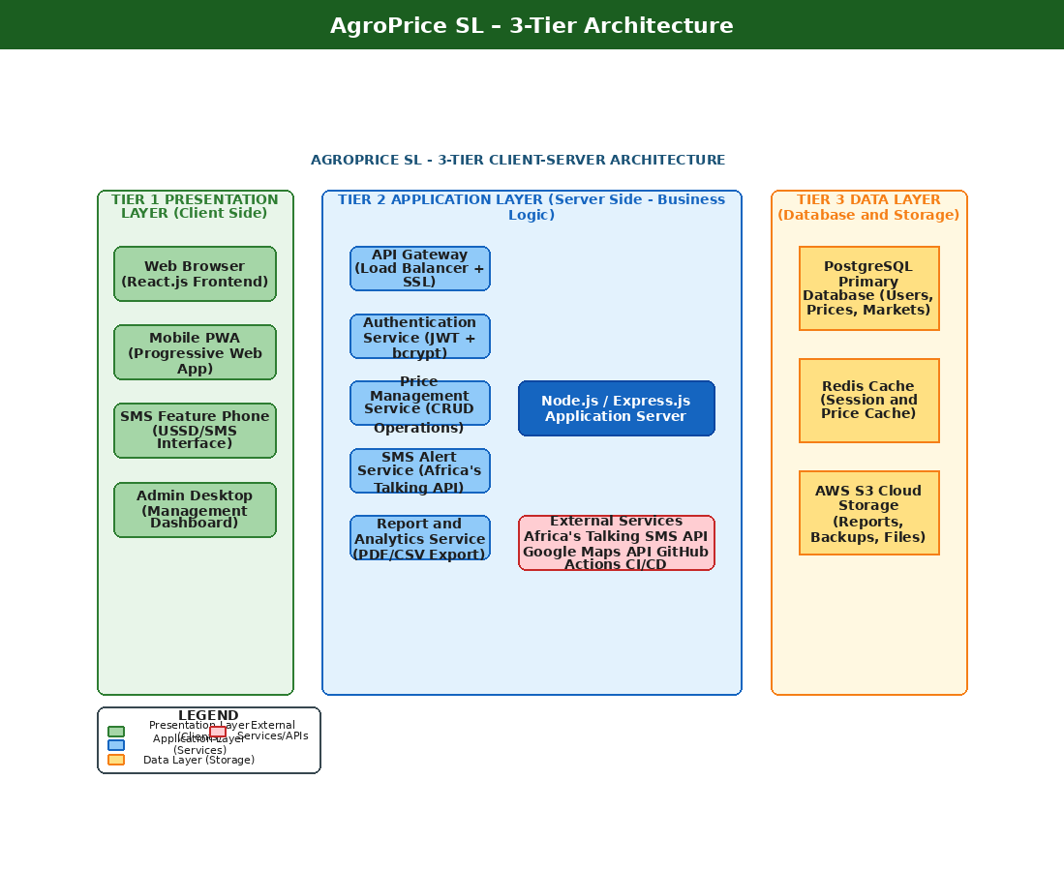

3.3 Use Case Diagram
Figure 2: Use Case Diagram – showing all actors (Farmer, Market Officer, Admin) and their system interactions.
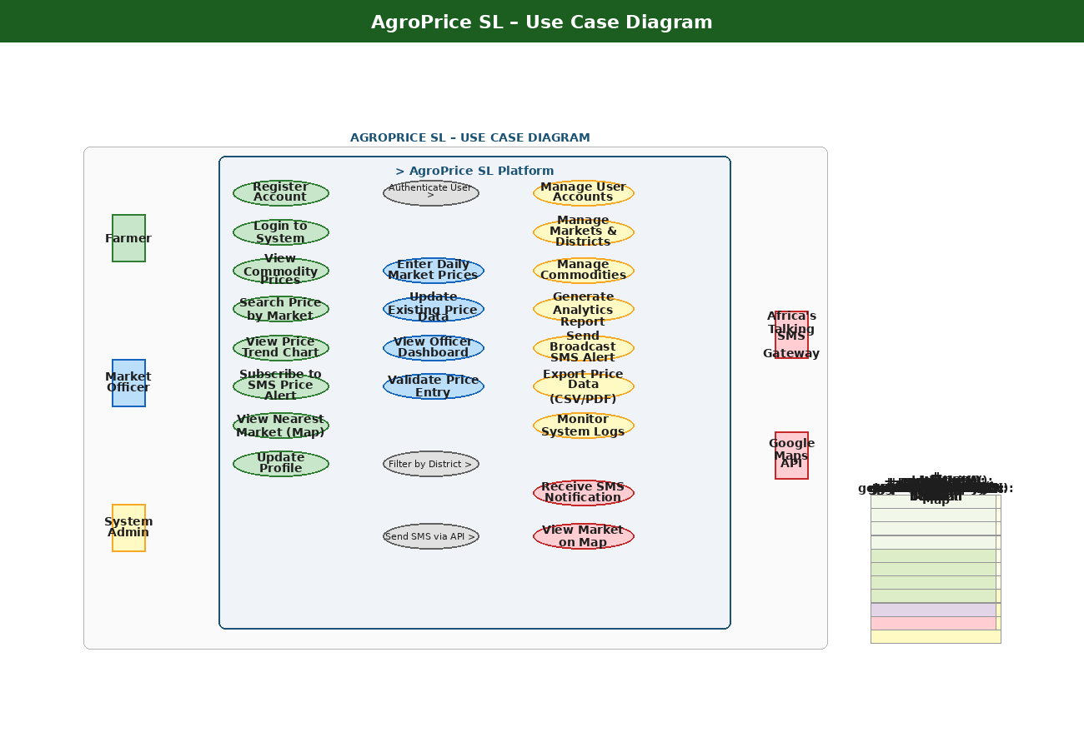

3.4 Class Diagram
Figure 3: Class Diagram – showing core classes: User, Farmer, Commodity, Market, MarketPrice, SMSAlert, Report.
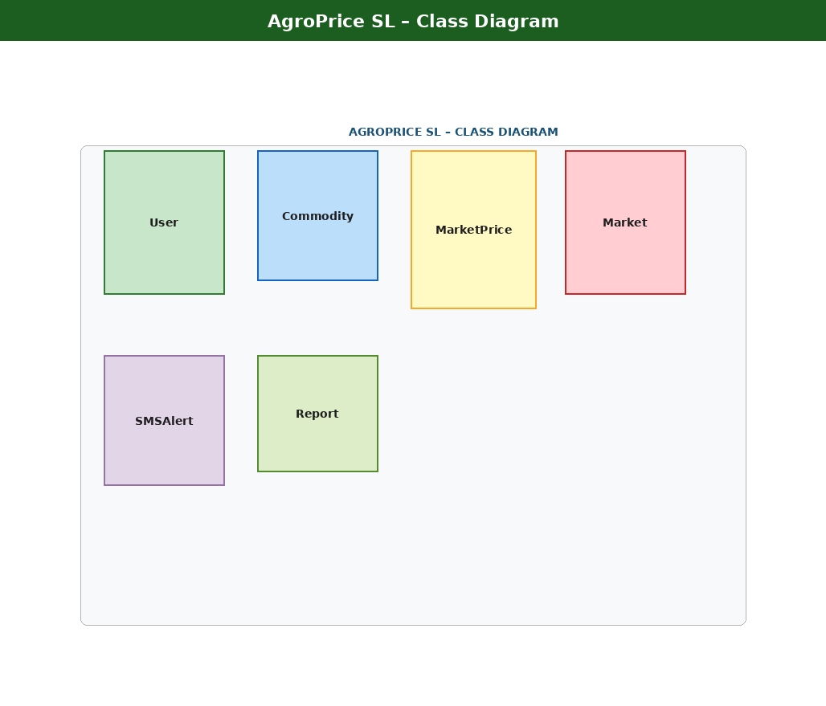

3.5 Sequence Diagram
Figure 4: Sequence Diagram – illustrating the price-viewing flow from Farmer → API → Database → Response.
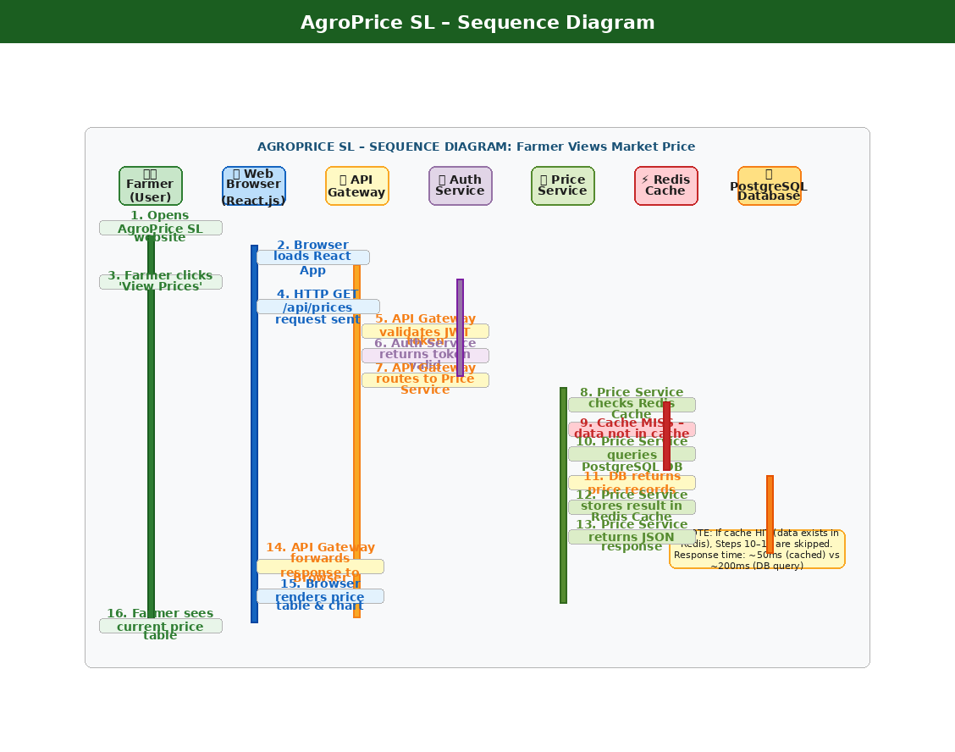

Chapter 4: Database Design

4.1 Overview
AgroPrice SL uses PostgreSQL 15 normalized to 3NF. The database has five core tables: USERS, COMMODITIES, MARKETS, MARKET_PRICES, and SMS_ALERTS.

4.2 Database ERD
Figure 5: Entity Relationship Diagram – showing all 5 tables with PK/FK relationships.
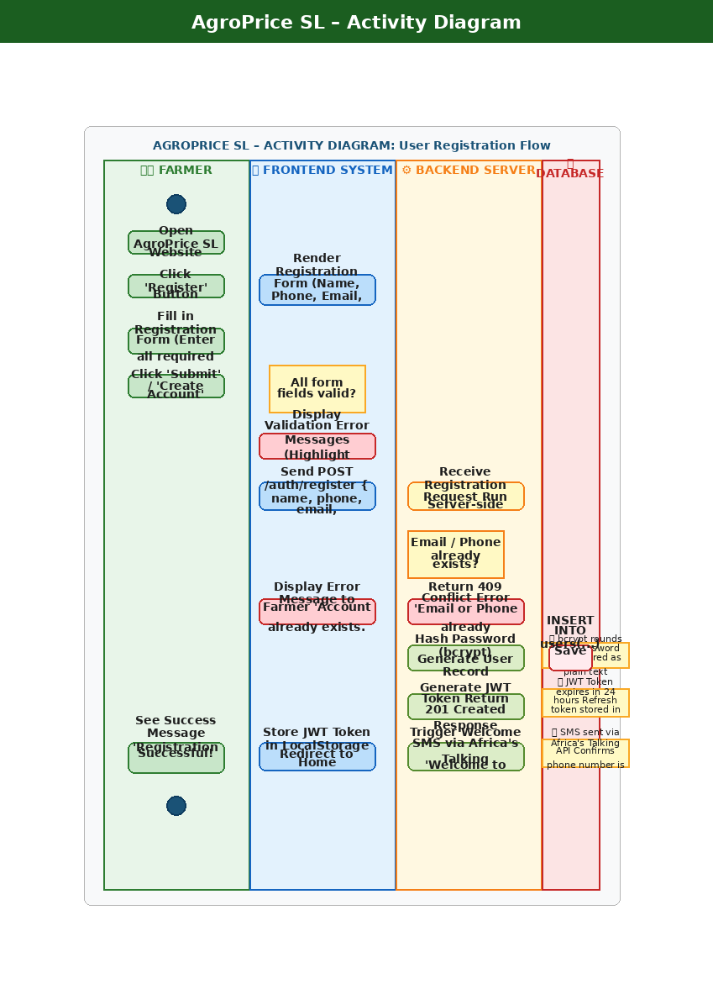

4.3 Key Table Schemas
USERS Table
Column | Type | Constraint
user_id | INT | PRIMARY KEY, AUTO_INCREMENT
full_name | VARCHAR(100) | NOT NULL
phone_number | VARCHAR(20) | UNIQUE, NOT NULL
role | ENUM | farmer | admin | officer | policymaker
password_hash | VARCHAR(255) | NOT NULL
district_id | INT | FOREIGN KEY

MARKET_PRICES Table (Core)
Column | Type | Constraint
price_id | INT | PRIMARY KEY, AUTO_INCREMENT
commodity_id | INT | FOREIGN KEY → COMMODITIES
market_id | INT | FOREIGN KEY → MARKETS
price_per_unit | DECIMAL(10,2) | NOT NULL
recorded_date | DATE | NOT NULL
trend | ENUM | rising | falling | stable
recorded_by | INT | FOREIGN KEY → USERS

Chapter 5: Prototype Development

5.1 Design Overview
The AgroPrice SL UI was designed in Figma following mobile-first, accessibility-focused principles. The design targets farmers with varying digital literacy levels, using large fonts, icon-based navigation, and a green agricultural colour palette. All 10 screens meet WCAG 2.1 AA accessibility standards.

5.2 Figma Link
https://www.figma.com/[insert-your-prototype-link-here]

5.3 Mobile Screens (Phone Prototype)
Figure 6: Figma Mobile Screens – Screens 1 to 5 (Splash, Login, Registration, Dashboard, Market Selection)
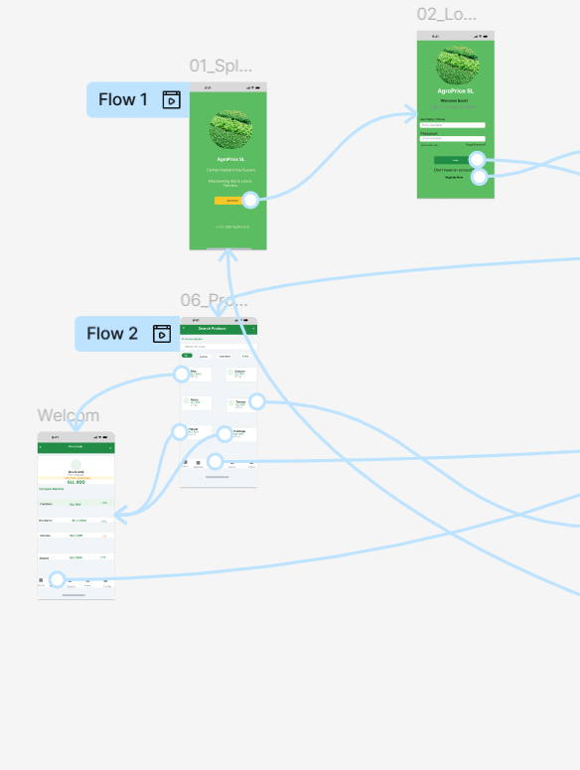

Figure 7: Figma Mobile Screens – Screens 6 to 10 (Produce Search, Price List, User Management, Profile)
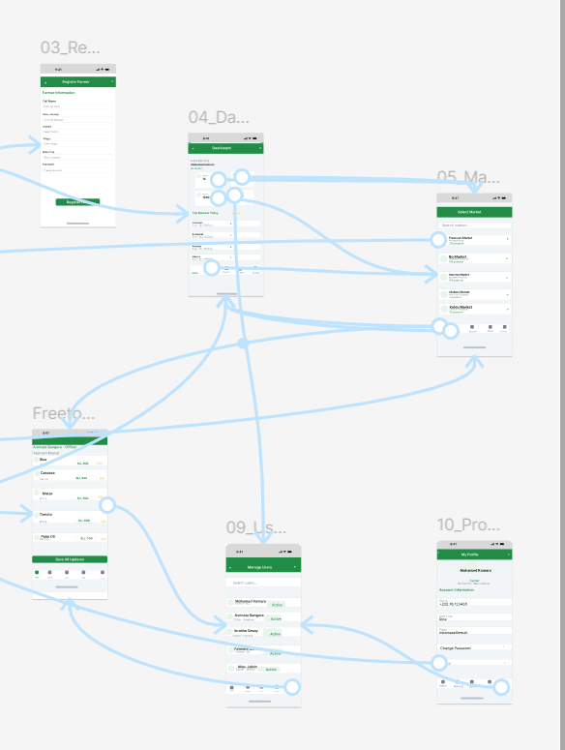

5.4 Desktop Screens
Figure 8: Figma Desktop Screens – Screens 1 to 5 (Welcome, Login, Registration, Dashboard, Market Selection)
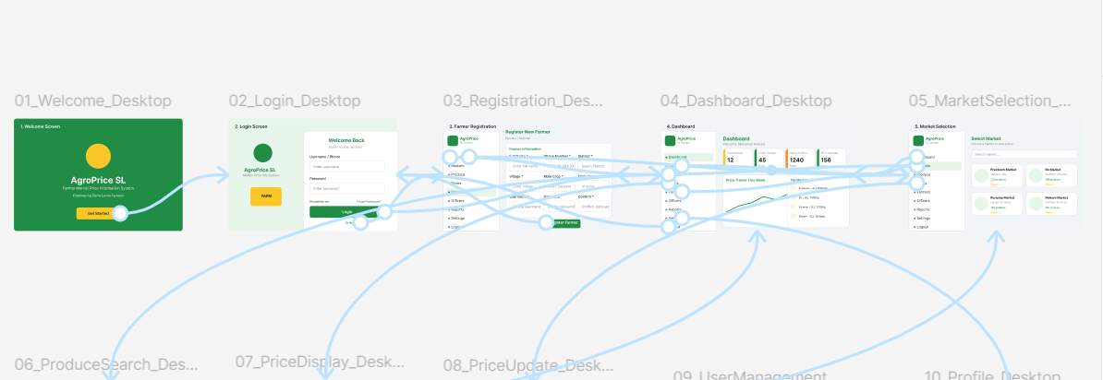

Figure 9: Figma Desktop Screens – Screens 6 to 10 (Produce Search, Price Display, Price Update, User Management, Profile)
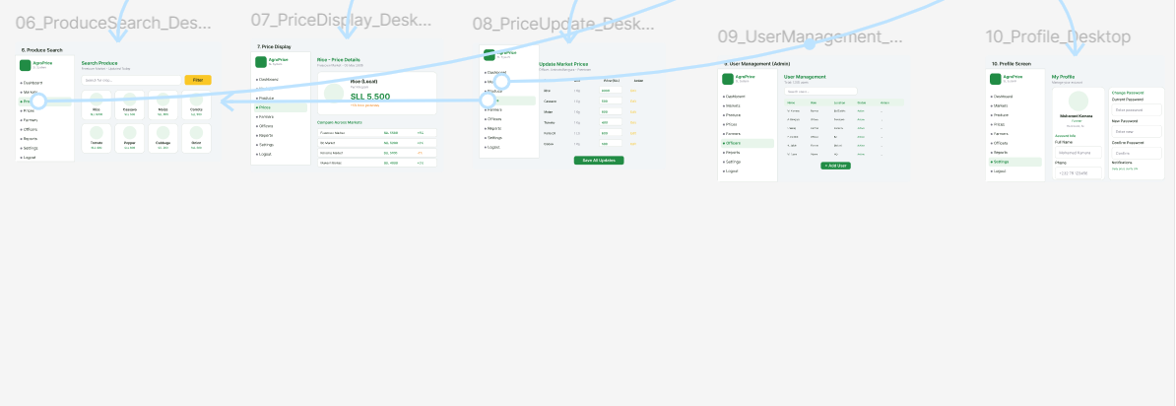

Chapter 6: Git & GitHub Integration

6.1 Repository Overview
Property | Detail
Repository Name | agroprice-sl
GitHub URL | https://github.com/[yourusername]/agroprice-sl
License | MIT License
Visibility | Public
Default Branch | Main

6.2 Repository Structure
agroprice-sl/ ├── docs/ (report, diagrams, ERD) ├── frontend/ (React.js src, components, pages) ├── backend/ (Node.js, Express, controllers, routes) ├── database/ (schema.sql) ├── prototype/ (Figma exports) ├── README.md └── LICENSE

6.3 Branch Strategy
- main — Production-ready stable code only
- develop — Integration branch for completed features
- feature/* — Individual branches per feature (e.g. feature/user-auth)
- hotfix/* — Emergency fix branches from main

6.4 GitHub Screenshot
Figure 10: Insert screenshot of your GitHub repository page here.

Chapter 7: Project Management

7.1 Project Activities
ID | Activity | Duration | Depends On
A | Project Planning & Requirements | 3 wks | –
B | System Architecture Design | 3 wks | A
C | UI/UX Prototype (Figma) | 2 wks | B
D | Database Design & Setup | 2 wks | B
E | GitHub Repository Setup | 1 wk | A
F | Frontend Development | 5 wks | C
G | Backend Development | 4 wks | D
H | SMS Alert Integration | 2 wks | G
I | Integration & Testing | 3 wks | F,G
J | Deployment | 1 wk | I
K | Documentation & Submission | 2 wks | J

Critical Path: START → A → B → C → F → I → J → K → END (Total: 19 Weeks)

7.2 Gantt Chart
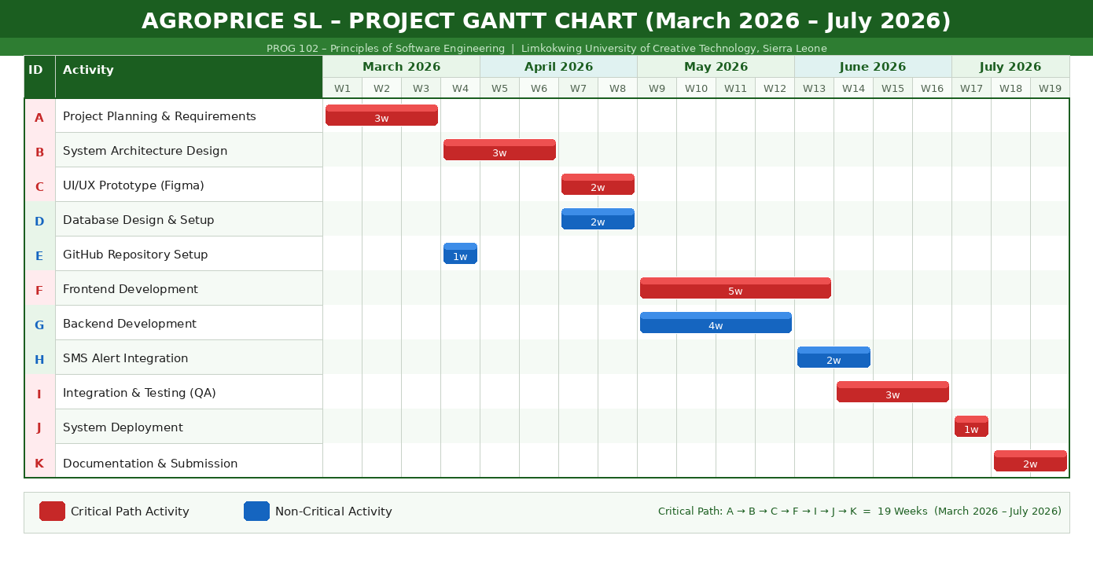

7.3 Network Diagram (CPM)
Figure 12: Network Diagram – Critical Path Method showing activity sequence and slack.
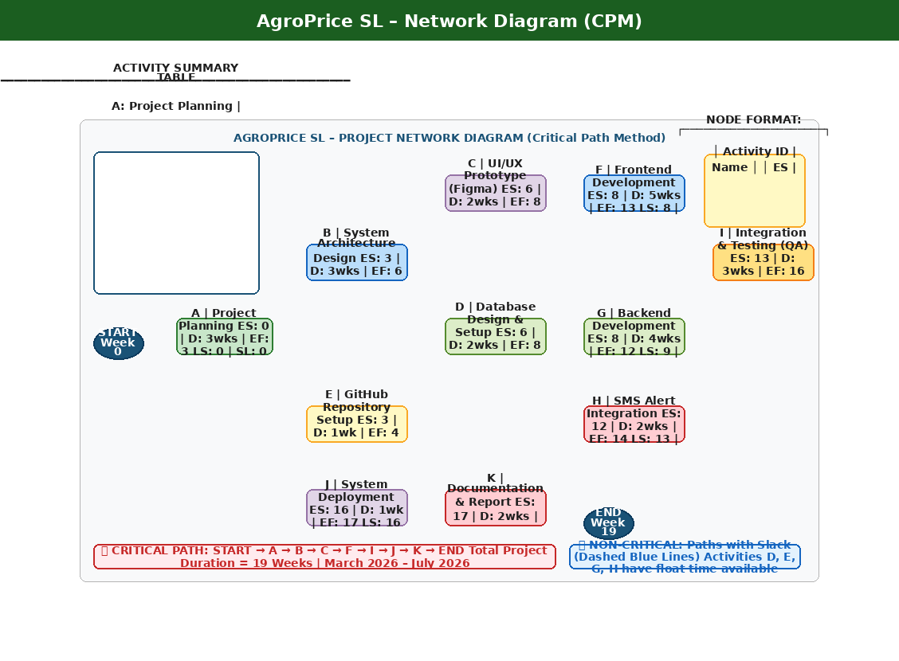

Chapter 8: License, Design Quality and SDG Relevance

8.1 Software License – MIT
AgroPrice SL is released under the MIT License, making it a true Digital Public Good. This permissive license allows governments, NGOs, and development partners to freely use, modify, redistribute, and deploy the system. It aligns with Digital Public Goods Alliance (DPGA) open licensing standards.

Resource | License | Usage
React.js | MIT | Frontend UI Framework
Node.js | MIT | Backend Runtime
PostgreSQL | PostgreSQL (Open Source) | Primary Database
Africa's Talking | Commercial SaaS | SMS Gateway
Chart.js | MIT | Analytics Charts
Bootstrap 5 | MIT | Responsive Design

8.2 UI/UX Design Quality
- Simplicity: Maximum 3 clicks to reach any core feature.
- Accessibility: WCAG 2.1 AA compliant, minimum 4.5:1 colour contrast.
- Responsiveness: Mobile-first design from 320px screen width.
- Agricultural Identity: Green palette builds trust and brand recognition.
- Typography: Poppins Bold (headings), Poppins Regular (body), Roboto Mono (prices).

8.3 SDG 1 Alignment Matrix
Problem in Sierra Leone | AgroPrice SL Solution | Impact
Farmers sell below market due to price ignorance | Real-time prices via web and SMS | 15–25% income increase
Middlemen exploit information gap | Transparent public price publishing | Fairer market transactions
Post-harvest losses from poor timing | Price trend analytics | Better selling decisions
Women farmers lack market access | SMS access via feature phones | Inclusive financial access
9: Conclusion and Recommendations

9.1 Summary
AgroPrice SL delivers a complete software design addressing market information inequality in Sierra Leone's agricultural sector. This project has successfully produced all seven required deliverables: SDLC documentation, system architecture, UML diagrams, database schema, Figma prototype, GitHub integration, and project management tools — all aligned to SDG 1: No Poverty.

9.3 Recommendations
- Integrate AI price prediction using historical commodity data.
- Add Krio, Mende, and Temne language support for broader reach.
- Seek Ministry of Agriculture endorsement and funding for district officers.
- Expand to Android app for improved offline capability.

9.4 Conclusion
AgroPrice SL is a practical, scalable, and impactful response to one of Sierra Leone's most persistent development challenges. Every farmer who receives an SMS price alert and uses it to negotiate a fair price moves one step further from poverty. This system is designed to make that happen — at scale, across Sierra Leone.

References

Agile Alliance. (2024). Agile Manifesto and Principles. Retrieved from https://agilemanifesto.org
Africa's Talking. (2026). SMS API Documentation. Retrieved from https://africastalking.com/docs
Digital Public Goods Alliance. (2024). DPG Standard and Open Licensing. Retrieved from https://digitalpublicgoods.net
Food and Agriculture Organization (FAO). (2023). Agricultural Market Information Systems in Sub-Saharan Africa. Rome: FAO.
Kamara, S.F. (2026). PROG 102 – Principles of Software Engineering: Course Materials. Limkokwing University, Sierra Leone.
Meta Open Source. (2024). React.js Documentation v18. Retrieved from https://react.dev
Node.js Foundation. (2024). Node.js v20 Documentation. Retrieved from https://nodejs.org/docs
PostgreSQL Global Development Group. (2024). PostgreSQL 15 Documentation. Retrieved from https://www.postgresql.org/docs
Pressman, R. S., & Maxim, B. R. (2020). Software Engineering: A Practitioner's Approach (9th ed.). McGraw-Hill.
Sommerville, I. (2019). Software Engineering (10th ed.). Pearson Education.
United Nations. (2015). Transforming Our World: The 2030 Agenda for Sustainable Development. UN.
World Bank. (2023). Sierra Leone Agricultural Sector Overview. Washington D.C.: World Bank Group.

